**Exploring the Economic Forces Driving the U.S. Housing Market**

**By: Pia Jain, Lunamia Bolanos, and Dhwani Agarwal**

**Project Context**

This project examines how macroeconomic variables, specifically interest rates, inflation, unemployment, and housing prices, shape the performance of real-estate related stocks. The goal of the analysis is to evaluate how shifts in monetary policy and economic conditions influence real estate market performance and to identify periods of opportunity or vulnerability for investment and expansion. Data was collected from multiple sources, stock prices from Yahoo Finance, macroeconomic indicators from the Federal Reserve Economic Data (FRED), and housing market data from the Federal Housing Finance Agency (FHFA). Together, these datasets reveal how financial markets and the real economy interact across different phases of the economic cycle.

**Macroeconomic Background**

Since the beginning of the COVID-19 pandemic in 2020, the Federal Reserve has made a major policy shift, transitioning from near-zero interest rates to one of the most aggressive tightening cycles in recent history. The Federal Funds Rate rose from 0.00%-0.25% at the end of December 2021 to around 4.5% in July 2025, as the Fed seeks to combat inflation that surged following supply chain disruptions and increased government spending. During this period, inflation (CPI) grew by roughly 24% between 2020 and 2025, while unemployment fell sharply after the 2020 spike and stabilized in the 3-4% range. These macroeconomic shifts directly influenced housing demand, mortgage affordability, and the performance of real estate investment trusts (REITs) and related equities.

**Stock Price Trends**

**Question:** How did varying interest-rate sensitivity across different real estate subsectors influence the performance of stocks like EQIX, PLD, ITB, O, and BAC from 2015 onward?

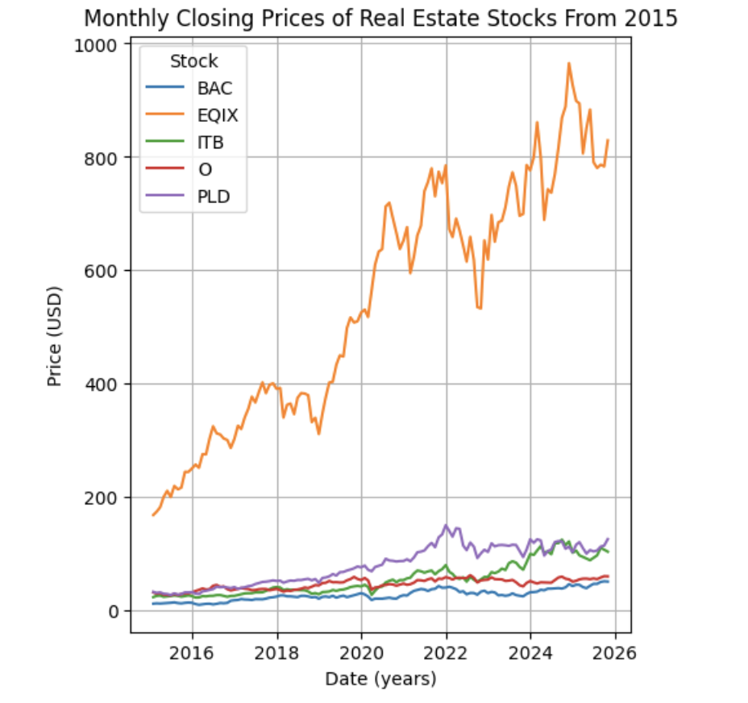

The first chart plots monthly closing prices for five major real estate-related securities, ITB, PLD, BAC, EQIX, and O, from 2015 onward. EQIX (Equinix) shows the highest price level and volatility, reflecting its tech-driven data center business that benefited from the surge in digital infrastructure demand during the pandemic. PLD (Prologis) demonstrates steady long-term appreciation, supported by e-commerce expansion and industrial demand. In contrast, ITB (Home Construction ETF) and O (Realty Income, a retail REIT) were more cyclical, rising sharply during the low-rate environment but flattening after 2022 as borrowing costs increased. BAC (Bank of America) remained relatively stable, mirroring financial-sector exposure to monetary tightening. Overall, the chart underscores how interest-rate sensitivity varies widely across real estate subsectors, with data-focused REITs proving more resilient than those tied to consumer or housing demand.

**Macroeconomic Trends (CPI, Unemployment, and Fed Funds Rate)**

**Question:** How do fluctuations in inflation, unemployment, and interest rates from 2015 to 2025 help explain the varying sensitivity of real estate investment sectors to changes in monetary policy and economic conditions?

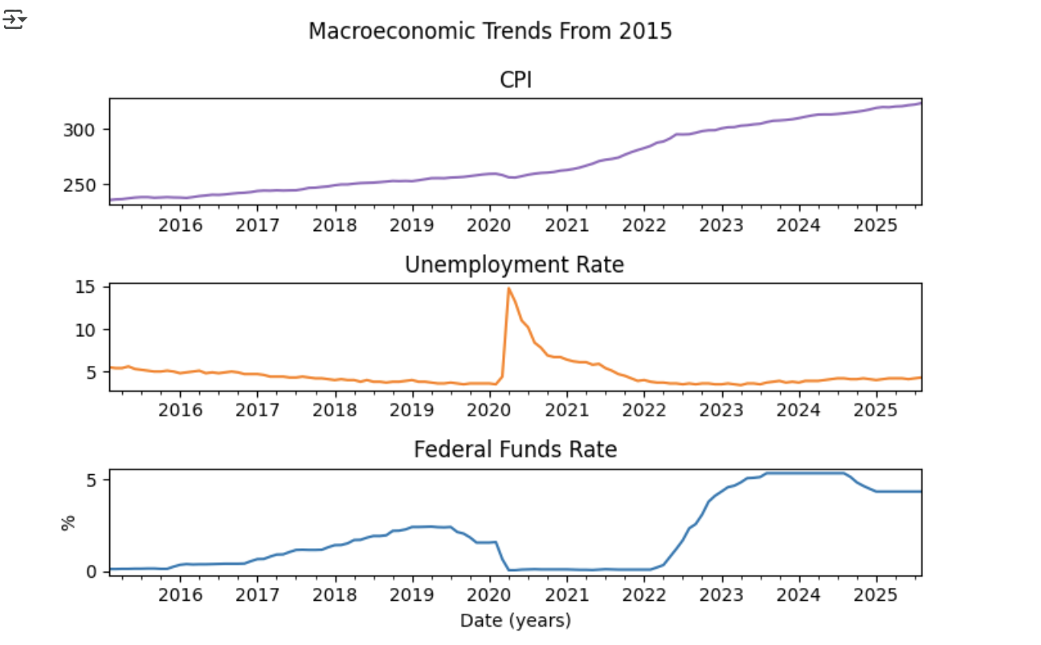

The macroeconomic trends chart displays how inflation, unemployment, and interest rates have evolved from 2015 to 2025. The Consumer Price Index (CPI) shows a steady rise throughout the decade, with the sharpest increase between 2021 and 2023 as inflation accelerated following pandemic disruptions and fiscal expansion. The Unemployment Rate spiked to nearly 15% in 2020 due to COVID-19 shutdowns but quickly declined as the labor market recovered, stabilizing around 4% in subsequent years. Meanwhile, the Federal Funds Rate remained low through most of the late 2010s and early 2020s before surging above 5% by 2023 as the Federal Reserve tightened policy to curb inflation. This visualization highlights the economic transition from a period of stability and stimulus to one of aggressive monetary tightening, something that directly shaped real estate market performance and REIT sector behavior.

**Correlation Matrices - Linking Markets and Macroeconomics**

**Question:** What does the correlation matrix suggest about the differing levels of sensitivity among real estate sectors to inflation, interest rates, and broader macroeconomic fluctuations?

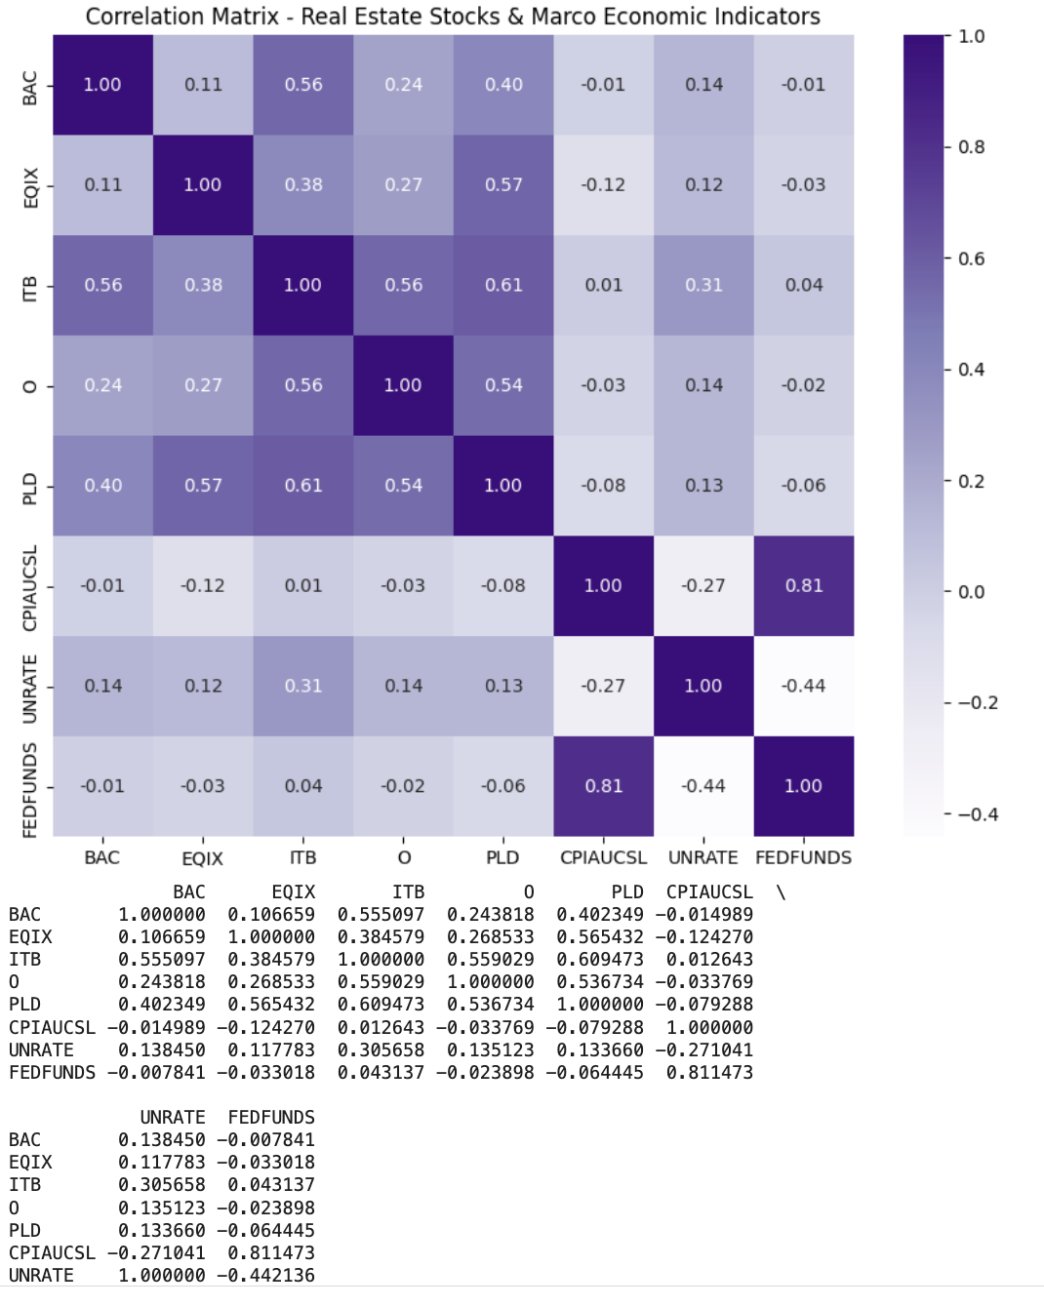

The correlation matrix quantifies the relationships between real estate stock performance and major macroeconomic indicators, helping reveal how closely financial markets move with shifts in inflation, interest rates, and employment. The results show a strong positive correlation between CPI and the Federal Funds Rate (r ≈ 0.81), confirming that higher inflation led the Federal Reserve to raise interest rates. In contrast, the Unemployment Rate is negatively correlated with both CPI and FEDFUNDS (r ≈ –0.44), illustrating the trade-off between inflation control and labor market strength.

Among the equities, ITB, PLD, and O show moderate positive correlations with one another, reflecting shared exposure to the broader housing and real estate sectors. EQIX, however, shows weaker correlations with both economic indicators and other REITs, consistent with its tech-oriented and data infrastructure focus, which makes it more resilient to macroeconomic shifts. Overall, the correlation matrix highlights that while higher rates and inflation tend to dampen short-term performance in most real estate assets, diversified or technology-linked REITs remain comparatively insulated from these cyclical pressures.

**FHFA House Price Index (2015-Present)**

**Question:** How does the FHFA House Price Index from 2015 to 2025 reflect the impact of changing interest rates on housing affordability and market momentum?

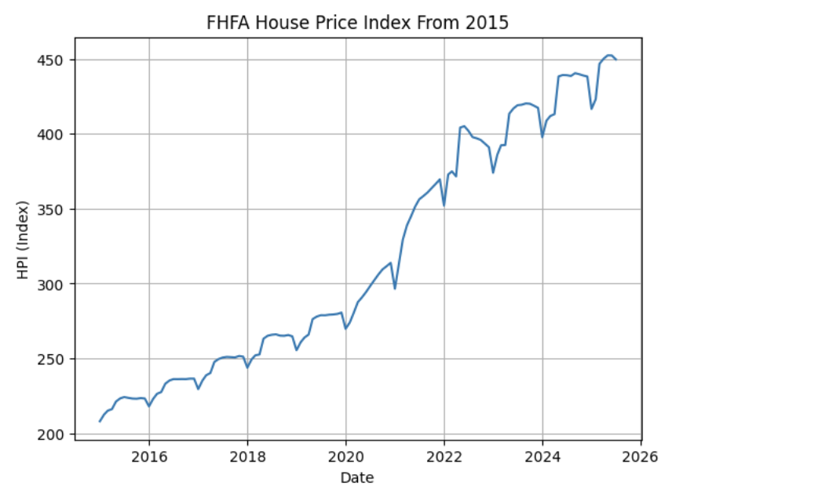

The FHFA House Price Index chart illustrates national home price trends from 2015 through 2025. The index shows a steady upward trajectory, rising from around 210 in 2015 to over 450 by 2025, marking a significant increase in housing values over the decade. The most rapid growth occurred between 2020 and 2022, driven by historically low interest rates, high demand, and limited housing supply during the pandemic. After the Federal Reserve began raising rates in 2022, the pace of appreciation slowed, and small fluctuations appeared between 2023 and 2025. This pattern suggests that while housing prices are highly sensitive to changes in borrowing costs, they also exhibit a lagged response, with prices continuing to climb for some time even after monetary tightening begins due to underlying supply-demand imbalances and delayed buyer adjustment.

**Correlation Matrix – Stocks, FHFA Index, and Macroeconomic Indicators**

**Question:** What does the correlation between the FHFA House Price Index, inflation, and interest rates reveal about the housing market’s resilience during periods of monetary tightening?

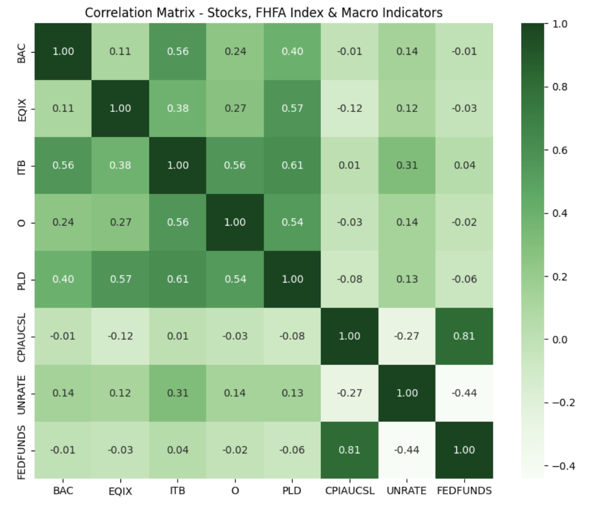

This correlation matrix illustrates the relationships between real estate-related stocks, the FHFA House Price Index, and key macroeconomic indicators such as inflation (CPI), unemployment (UNRATE), and the Federal Funds Rate (FEDFUNDS). The results show a strong positive correlation between CPI and FEDFUNDS (r ≈ 0.81), confirming that higher inflation has historically prompted the Federal Reserve to raise interest rates. Similarly, the negative correlation between unemployment and both CPI and FEDFUNDS (r ≈ –0.27 to –0.44) highlights the trade-off between inflation control and labor market strength.

Across equities, ITB, PLD, and O exhibit moderate positive correlations with one another, indicating that these real estate and housing-focused assets respond similarly to macroeconomic shifts. In contrast, EQIX, which operates in the data center space, shows weaker correlations with the broader market and economic indicators, reflecting its relative insulation from traditional rate and housing cycles. The FHFA House Price Index correlates positively with CPI and interest rates, suggesting that while higher rates eventually slow price growth, housing values have remained elevated during inflationary periods due to persistent supply shortages and structural demand.

**Predicted vs. Actual House Price Index (NSA)**

**Question:** How accurately does the predictive model capture real housing price trends, and what might explain the small discrepancies between the predicted and actual FHFA House Price Index values?

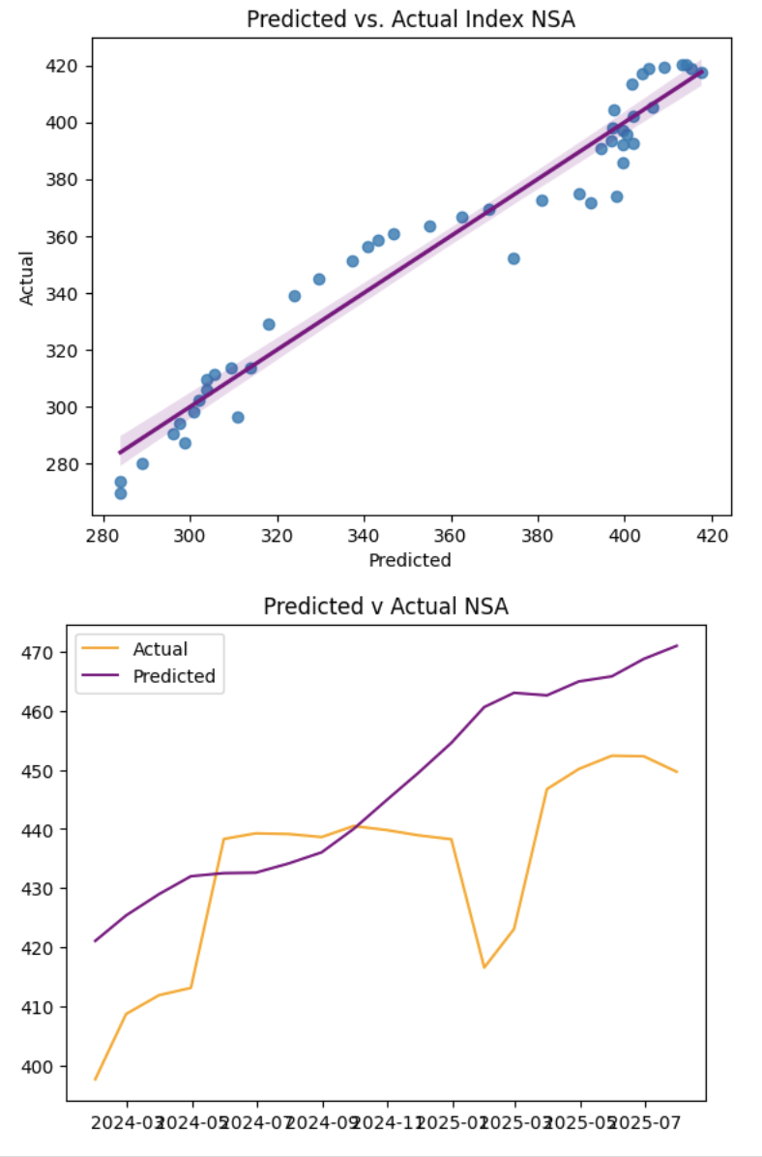

The two plots compare the predicted and actual values of the non-seasonally adjusted FHFA House Price Index to assess how well the model tracks real housing market trends. The scatter plot shows a strong linear relationship between predicted and observed values, indicating that the model effectively captures key drivers such as interest rates, inflation, and income trends. Similarly, the time-series plot demonstrates that both lines move in tandem, confirming the model’s ability to mirror overall price dynamics. However, the predicted values slightly overestimate prices toward 2025, suggesting that the model may not fully account for lagged market responses to higher interest rates and affordability constraints. Overall, the model provides an accurate representation of housing price movements, with only minor deviations during periods of economic transition.

**Predicted vs. Actual PLD Stock Prices**

**Question:** To what extent can macroeconomic variables alone explain movements in PLD’s stock price, and what additional factors might improve the accuracy of these predictions?

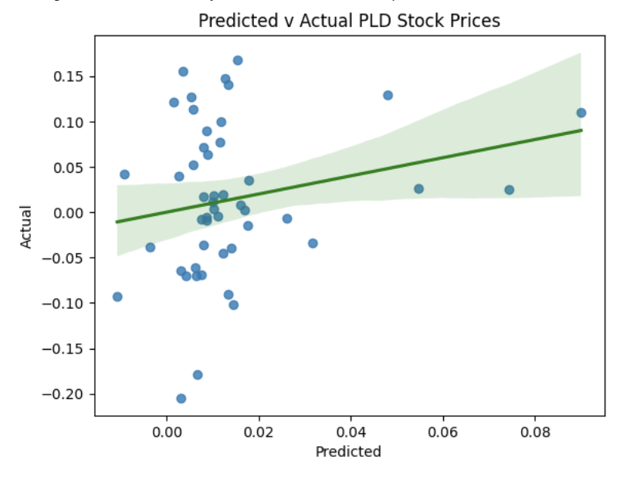

This scatter plot compares the predicted and actual stock price movements for PLD to assess how accurately the model captures its market behavior. The results show a weak but positive correlation, with the regression line trending upward, indicating that the model can generally predict the direction of change but not the precise magnitude. The wide spread of data points around the line suggests that PLD’s stock performance is influenced by additional factors, such as market sentiment, company earnings, and global logistics demand, that extends beyond the macroeconomic indicators included in the model. Overall, the model offers a limited but meaningful ability to forecast PLD’s price trends within a broader economic context.

**Interpretation**

​​Together, these visuals paint a cohesive narrative of the real estate cycle under monetary tightening. During the lower phase of 2020 to 2021, real estate and housing-related stocks thrived as borrowing was cheap and liquidity abundant. As inflation surged in 2022-2023, the Fed’s rapid rate hikes curbed momentum, house prices leveled off, and returns across rate-sensitive REITs and homebuilders weakened. By 2025, the data suggests a stabilizing phase, inflation has cooled, rates have plateaued, and real estate equities are positioned for gradual recovery. These findings imply that the optimal market-entry window for real estate expansion is typically after the rate peak, when financing begins to ease and valuations remain moderate. Moreover, tech-oriented and industrial REITs such as EQIX and PLD offer more defensive exposure compared to cyclical housing or retail assets.